**Tools used to develop my prototypes**

**Project for prototypes: Traceball**

For this document, I will be analysing the tools that I used to help create my prototypes for my Traceball software and why they were used.

**Tools I used**

To develop the software, I wanted to prototype the UI of the game, this is because I wanted to build the software with a good idea of how it was going to look, these prototypes were very helpful when designing a UI with the game.

[**https://wireframe.cc/**](https://wireframe.cc/)

To have a Low Fidelity prototype, I used a website called WireFrame.cc, this website allowed me to create a very basic UI for the game, it offered methods of drag and drop shape and text placement which combining the features I was able to get a basic prototype of the UI. I chose to use Wireframe because it was free, easy to use and I could access it anywhere if I have an internet connection allowing it to be worked on from multiple locations.

**First prototype**

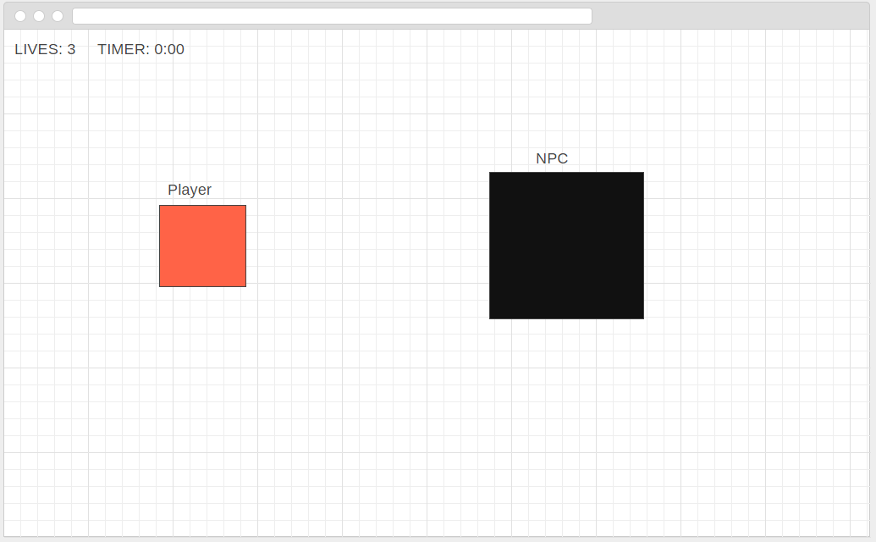

This was my Low Fidelity prototype, low fidelity prototypes are known as rough and very simple prototypes, low fidelity prototypes are usually the first types as they are designed for planning and making design choices, as they are simple they can be changed if there is a problem.

My first Low fidelity prototype of the UI was enough to give me an idea of how the layout of the game would look, having one small orange coloured box and one large black coloured box, both boxes are labelled with either ‘Player’ or ‘NPC’ to show which box is designed to fill which role. By creating this I was able to work with a base for the design for the game and continue to build the game itself.

**Draw.io**

The second tool I used was ‘Draw.io’, this was because of the functionality it gave to make better prototypes, draw.io allowed me to implement arrows for directions and gave me a lot more freedom in how I created my UI and planned out the game mechanics. Like Wireframe.cc it is free and only requires an internet connection to be used.

**Second Prototype**

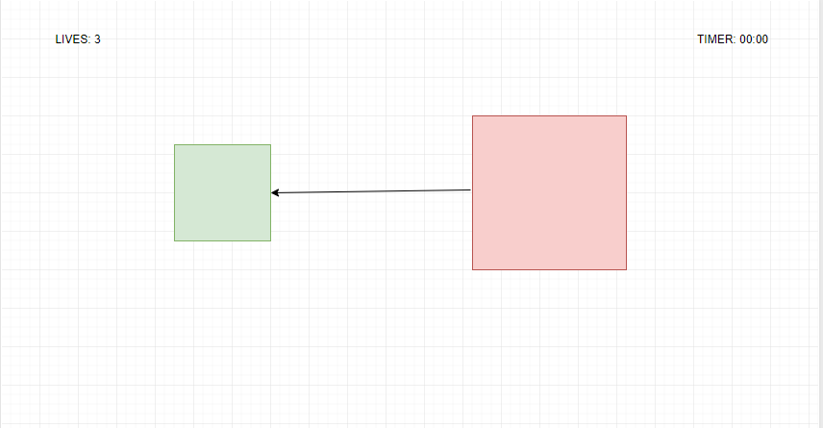

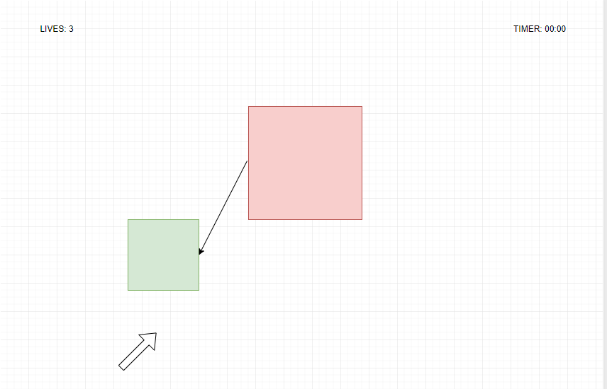

This wireframe for my second prototype on the Traceball game was to show how the chasing would occur from the NPC coming to the player and how the movement would work. I also at this point had changed the colours for the squares to make it clearer for the player which square belongs to which role.

**Third Prototype**

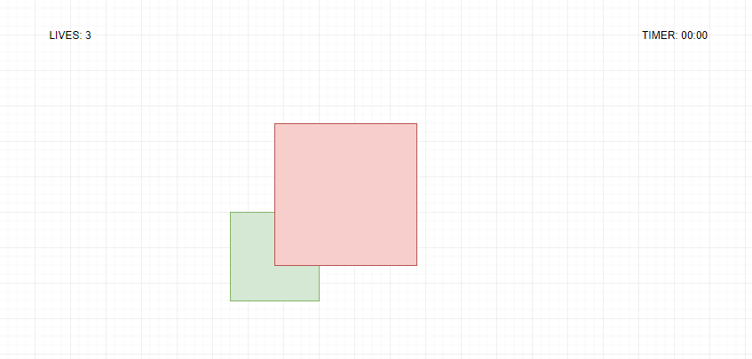

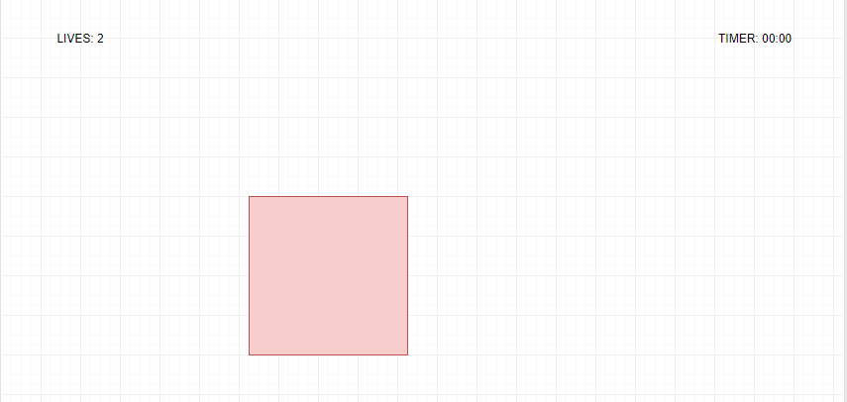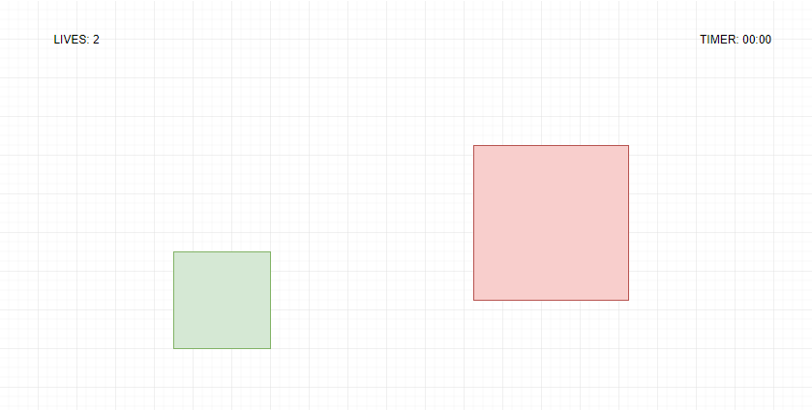

The wireframe for my third prototype was created to plan how unit collision would be presented and how the game would react to being caught. It was planned that by having the green square completely consumed by the red square, the player would lose a life and the squares would be reset. There is not scoring system and progress is judged by the how far the timer has gone.

**Using Repl.it and Creating prototypes from wireframes**

After having low fidelity prototypes, I developed the high-fidelity prototypes, high fidelity is meant to be a neat and accurate version of the product from when the prototype was made. For my high-fidelity prototypes, I used ‘Repl.IT’ for my IDE, this website allowed for me to code my prototypes easily whilst having its own cloud storage meaning that my work could be saved to my account and accessed anyway. With this the website offered Syntax Highlighting, in-built debugger and ran any code quickly. The website is free for an account and could be accessed anywhere with an internet connection.